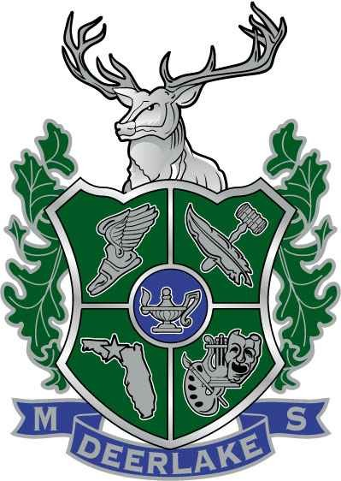
Deerlake Middle School
2022 Summer Recommended Summer Reading

Dear Students,

Reading is an avenue for exploring diverse cultures and shared experiences. Reading is crucial to your continuing academic success and we believe that recreational reading enriches your personal life. Research shows that students improve their reading skills through practice. All students entering grades six through eight should read at least one book this summer. The goal of our recommended summer reading is to challenge, motivate, and entertain students in order to create life-long readers. The book lists can be found at local libraries and book stores.

Summer reading is recommended for all students and is expected to be completed by the first day of school. During the first week of school, students will complete an in-class book review. To assist with understanding the text, graphic organizers should be used to analyze the main characters and track the events occurring within the text. Both Graphic organizers are to be submitted the first day of school. (Beginning, Middle, End: Use the 3 boxes on the left to retell what happens in the story. The boxes on the right are for additional details. Character Analysis: While reading the novel, take notes on each main character.)

We wish you a wonderful summer and look forward to seeing you this fall!

Sunshine State Young Reader Award Books for upcoming 6-8 graders
Amari and the Night Brothers by B.B. Alson
Archimancy Shadow School by J.A. White
Concealed by Christina Diaz Gonzalez
Curse of the Night Witch by Alex Aster
Double the Dancer and Zero Zucchini by Betsy Uhrig
Dragon Ops by Mari Mancusi
The Elephant in the Room by Holly Goldberg Sloan
Lola Benko, Treasure Hunter by Beth McMullen
Pixie Pushes On by Tamara Bundy
Quintessence by Jess Redman
Rivals by Tommy Greenwald
Scritch Scratch by Lindsay Currie
The Smartest Kid in the Universe by Chris Grabenstein
Starfish by Lisa Fipps
Words on Fire by Jennifer Neilsen

